SIMATS ENGINEERING (SAVEETHA SCHOOL OF ENGINEERING)
Department of Computer Science and Engineering
CO3 ASSESSMENT TOOL 2 – Code Review & Repository Evaluation

Course Code: | CSA10 / CSA1063 | Course Title: | Software Engineering
CO Assessed: | CO3 | Assessment: | Assessment Tool 1 – Code Review & Repository Evaluation
Weightage: | 20% | Total Marks: | 25
CO3 Statement: | Build full-stack applications with an emphasis on containerization, version control, and collaborative development
Student Name: | M Dhanush kumar | Reg. No.: | 192525318
Date: | 15/08/26 | Duration: | 60 minutes

Code of Conduct
I ___(M Dhanush kumar/192525318)____ (Name / Reg No) certify that this submission is my original work and that I have adhered to the guidelines specified for this assessment. I understand that any violation of academic integrity rules will result in disciplinary action.
Signature of the Student: M Dhanush kumar
Annexure A – Code Review & Repository Evaluation
Instructions to Students:
Each student has been assigned an individual problem statement. Based on the assigned problem statement, perform a Code Review and Repository Evaluation of your project. Analyze the quality of the source code, repository organization, documentation, coding practices, and overall maintainability. Provide appropriate screenshots, code snippets, diagrams, and justifications wherever applicable.

Assignment Questions
- Problem Overview
  - Explain the assigned problem statement and summarize the implemented solution.
  - Describe the project objectives and key functionalities.
- Repository Organization
  - Evaluate the repository structure, folder organization, and file naming conventions.
  - Justify how the repository layout supports maintainability and collaboration.
- Code Quality Review
  - Review the source code for readability, modularity, coding standards, and documentation.
  - Identify strengths and areas for improvement.
- Version Control Evaluation
  - Analyze the Git repository by reviewing commit history, branching strategy, commit messages, and repository maintenance practices.
  - Explain how version control supports collaborative software development.
- Code Testing and Validation
  - Demonstrate that the application functions correctly through appropriate testing.
  - Present test cases, execution results, and screenshots as evidence.
- Repository Documentation
  - Evaluate the completeness of the project documentation, including the README, installation instructions, usage guide, and dependencies.
  - Suggest improvements to enhance usability and maintainability.
- Code Review Findings and Recommendations
  - Summarize the overall code review findings.
  - Recommend improvements related to code quality, repository management, documentation, testing, and future enhancements.

Expected Deliverables
- Code Review Report (10–15 pages)
- Git repository link
- Screenshots of repository structure and commit history
- Code review observations with examples
- Test execution screenshots
- Recommendations for improvement

Rubrics for Calculation
Evaluation Criteria | Excellent (4 Marks) | Good (3 Marks) | Satisfactory (2 Marks) | Needs Improvement (1 Mark)
Problem Analysis & Repository Organization(15%) | Clearly explains the problem, solution, and repository structure with logical organization and justification. | Good explanation with minor omissions. | Basic explanation and repository organization. | Incomplete or poorly organized repository.
Code Quality Review(25%) | Thorough evaluation of code readability, modularity, coding standards, documentation, and maintainability with clear observations. | Good code review with minor gaps. | Basic review with limited analysis. | Superficial or inaccurate code review.
Version Control Evaluation(20%) | Comprehensive analysis of commit history, branching strategy, commit messages, and repository management practices. | Good evaluation with adequate explanation. | Basic evaluation with limited evidence. | Poor or incomplete version control analysis.
Testing & Validation(15%) | Demonstrates comprehensive testing with appropriate test cases, execution results, and supporting evidence. | Good testing with minor omissions. | Basic testing with limited evidence. | Inadequate or missing testing and validation.
Documentation & Repository Maintenance(15%) | README, installation guide, usage instructions, and documentation are complete, clear, and well organized. | Documentation is mostly complete. | Basic documentation with missing details. | Poor or insufficient documentation.
Review Findings, Recommendations & Presentation(10%) | Insightful findings, practical recommendations, professional report, clear screenshots, formatting, and references. | Good recommendations and presentation. | Basic recommendations with acceptable presentation. | Weak conclusions and poor presentation.

Criteria | Mark
System Requirement Analysis (30%) | /5
Selection of Software Architecture (25%) | /5
Architecture Diagram and Component Design (20%) | /5
Component Interaction and Quality Attribute Analysis (15%) | /5
Architectural Justification and Technical Presentation (10%) | /5
TOTAL | /25

SOFTWARE ENGINEERING – ASSESSMENT TOOL 2(CO3)

NAME: M Dhanush Kumar
REG NO: 192525328
COURSE CODE: CSA1007
PROBLEM NO: 23
TITLE: SMART VERTICAL FARMING AUTOMATION PLATFORM

- PROBLEM OVERVIEW & SOLUTION SUMMARY

- PROBLEM STATEMENT:-
  - Design and develop a distributed Smart Vertical Farming Automation Platform that continuously acquires real-time operational data from environmental sensors, farming devices, and users while supporting secure, scalable, and fault-tolerant operations.

- IMPLEMENTED SOLUTION:-
  - A containerized microservices architecture utilizing an IoT sensor gateway for real-time farm environment monitoring, an AI/ML predictive analytics module for crop health and growth prediction, a centralized alerting and control hub, and an interactive farming dashboard.

- KEY FUNCTIONALITIES:-
  - Real-time data acquisition from farm sensors, automated environmental anomaly detection, predictive crop and resource analytics, real-time farmer alerting, and centralized crop and system performance reporting.

2. REPOSITORY ORGANIZATION

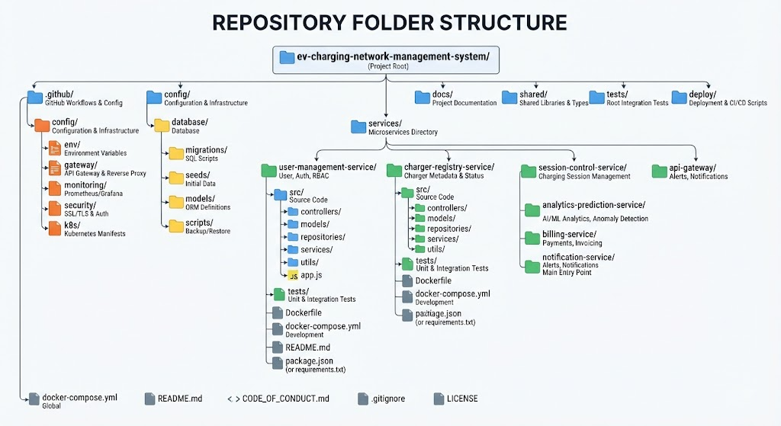

3. CODE QUALITY REVIEW:-

- Readability & Modularity: Source code modules adhere to strict separation of concerns, isolating database connection logic from route controllers and business services.

- Coding Standards & Documentation: Code adheres to PEP8 standards (Python services) and ESLint/Prettier configurations (React dashboard). Inline documentation and JSDoc/Docstring headers are used extensively.

- Strengths: High modularity, robust error-handling middleware, and clear separation between real-time data ingestion and long-term analytics.

- Areas for Improvement: Expanding unit test coverage for edge-case WebSocket disconnections and adding stricter type validation schemas on incoming IoT telemetry payloads.

4. VERSION CONTROL EVALUATION

- Branching Strategy: Implemented a structured Git Flow model featuring main (production), development (integration), and targeted feature/* branches for isolated module development.

- Commit History & Practices: Commits follow standard conventional commit message guidelines (e.g., feat(gateway): implement websocket reconnection logic, fix(auth): resolve jwt token expiration bug).

- Collaborative Benefits: Version control safeguards code integrity through mandatory pull request reviews, automated CI/CD checks, and traceable historical records.

5. CODE TESTING AND VALIDATION:-
- Testing Methodology: Validated using unit testing suites (PyTest for backend services, Jest for frontend components) alongside integration testing via Docker Compose.

- EXECUTION EVIDENCE & TEST CASES:

Test Case ID | Component | Test Scenario | Expected Result | Status
TC-01 | IoT Sensor Gateway | Establish persistent connection with simulated farm sensors | Successful sensor connection and telemetry response | PASSED
TC-02 | Core Farming API | Farmer authentication via username / JWT token | Access granted or unauthorized rejection | PASSED
TC-03 | AI/ML Crop Module | Ingest abnormal temperature and humidity readings from telemetry stream | Trigger automated irrigation or alert action | PASSED

6. REPOSITORY DOCUMENTATION & MAINTENANCE:-

- Documentation Completeness: The README.md features clear architecture overviews, prerequisite checklists, local installation instructions, and environment variable configuration guides.

- Usability Enhancements: Recommended adding troubleshooting sections for common Docker network binding conflicts and step-by-step instructions for running automated integration test suites.

7.CODE REVIEW FINDINGS AND RECOMMENDATIONS

- Summary of Findings: The repository demonstrates high engineering rigor, clean microservices isolation, and solid version control practices.

- Recommendations for Future Enhancements:

  - Integrate Vehicle-to-Grid (V2G) energy distribution logic into the core scheduling engine.

  - Implement dynamic AI-based irrigation and lighting schedules based on real-time crop conditions.

  - Enhance deep learning pipelines for advanced crop growth and yield forecasting.

